Physical Action

🔹 What is Physical Actions
# Source: AI Source: Provided by: [Data Path: Persons Table -> ID Column: 1, Name_En Column: Motasem Essam] -> From: [Chatgpt (GPT-4-turbo)] on [7/27/2025]
Physical action verbs are verbs that describe actions you can see, touch, or physically perform with your body or objects. These verbs involve real, visible movement.

✅ Definition:
# Source: AI Source: Provided by: [Data Path: Persons Table -> ID Column: 1, Name_En Column: Motasem Essam] -> From: [Chatgpt (GPT-4-turbo)] on [7/27/2025]
A physical action verb expresses a concrete, observable activity done by someone or something.

🏃 Key Idea:
# Source: AI Source: Provided by: [Data Path: Persons Table -> ID Column: 1, Name_En Column: Motasem Essam] -> From: [Chatgpt (GPT-4-turbo)] on [7/27/2025]
If you can see it happening or do it with your body, it’s usually a physical action verb.

📚 Examples of Physical Action Verbs:
# Source: AI Source: Provided by: [Data Path: Persons Table -> ID Column: 1, Name_En Column: Motasem Essam] -> From: [Chatgpt (GPT-4-turbo)] on [7/27/2025]
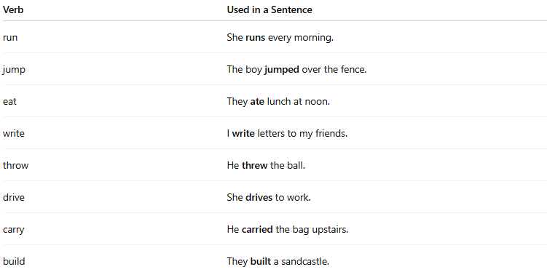
Verb | Used in a Sentence
run | She runs every morning.
jump | The boy jumped over the fence.
eat | They ate lunch at noon.
write | I write letters to my friends.
throw | He threw the ball.
drive | She drives to work.
carry | He carried the bag upstairs.
build | They built a sandcastle.

🧠 Test for Physical Action Verbs:
# Source: AI Source: Provided by: [Data Path: Persons Table -> ID Column: 1, Name_En Column: Motasem Essam] -> From: [Chatgpt (GPT-4-turbo)] on [7/27/2025]
Ask:
- Can you physically see or act out the verb?
- Does the verb involve bodily movement or physical activity?
✅ If yes → it’s a physical action verb.

🆚 Physical vs. Mental Action Verbs:
# Source: AI Source: Provided by: [Data Path: Persons Table -> ID Column: 1, Name_En Column: Motasem Essam] -> From: [Chatgpt (GPT-4-turbo)] on [7/27/2025]
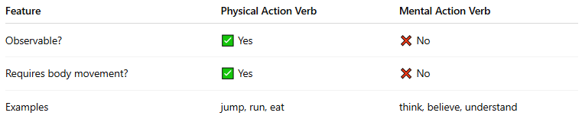
Feature | Physical Action Verb | Mental Action Verb
Observable? | ✅ Yes | ❌ No
Requires body movement? | ✅ Yes | ❌ No
Examples | jump, run, eat | think, believe, understand

✅ Summary:
# Source: AI Source: Provided by: [Data Path: Persons Table -> ID Column: 1, Name_En Column: Motasem Essam] -> From: [Chatgpt (GPT-4-turbo)] on [7/27/2025]
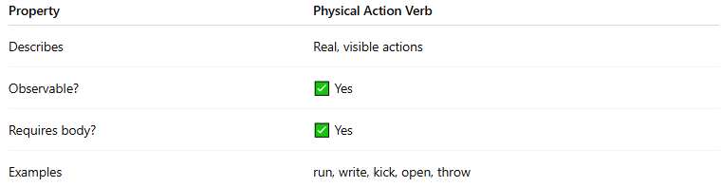
Property | Physical Action Verb
Describes | Real, visible actions
Observable? | ✅ Yes
Requires body? | ✅ Yes
Examples | run, write, kick, open, throw

